<http://thecastlereagh.blogspot.com.au/2012/09/yarrigan-fire-tower.html>

[Sep 29](http://thecastlereagh.blogspot.com/2012/09/yarrigan-fire-tower.html" \o "29th September 2012)

[**Yarrigan Fire Tower**](http://thecastlereagh.blogspot.com/2012/09/yarrigan-fire-tower.html)

Sitting high on an outcrop of the Warrumbungle Range Yarrigan Fire tower was the tallest of the observation towers constructed in the Pilliga Forest during the 1930s. The original wooden tower, overlooking the southern sections of the forest, was equipped with radio equipment to communicate with the forest headquarters at Baradine. A lookout keeper was stationed at the tower during the fire season. He was accommodated in a timber hut located on spur of east of the tower. The hut has been removed with only the stump of its chimney remaining. A new steel tower was constructed in the 1970s. This tower continues in use.

[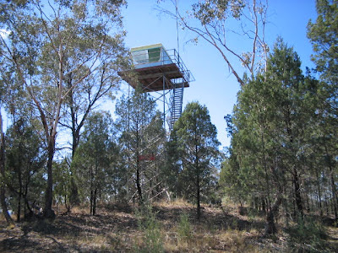](http://4.bp.blogspot.com/-6NVNvty7zpA/UGbWo084TEI/AAAAAAAABlM/CuT3NpIyaww/s1600/1391228b1.JPG)

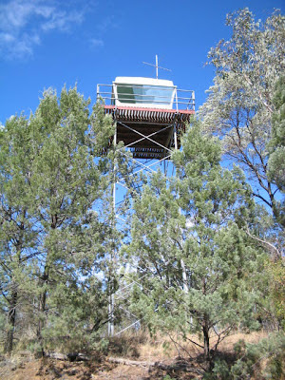

Posted 29th September 2012 by [Jose the travelling padre](http://www.blogger.com/profile/17328003063287040954)